**NAME:** ASJID TAHIR

**CLASS:** BSCS   
**SECTION:** 2B2  
**ROLL NO:** 19P-0085  
**SEMESTER:** 02  
**LAB TASKS:**  
 DIGITAL LOGIC DESIGN

**TOPIC:**  
 1 & 2 & 4 BIT MAGNTUDE COMPARATOR

**TASK NO 1:**

**1 bit magnitude comparator:**

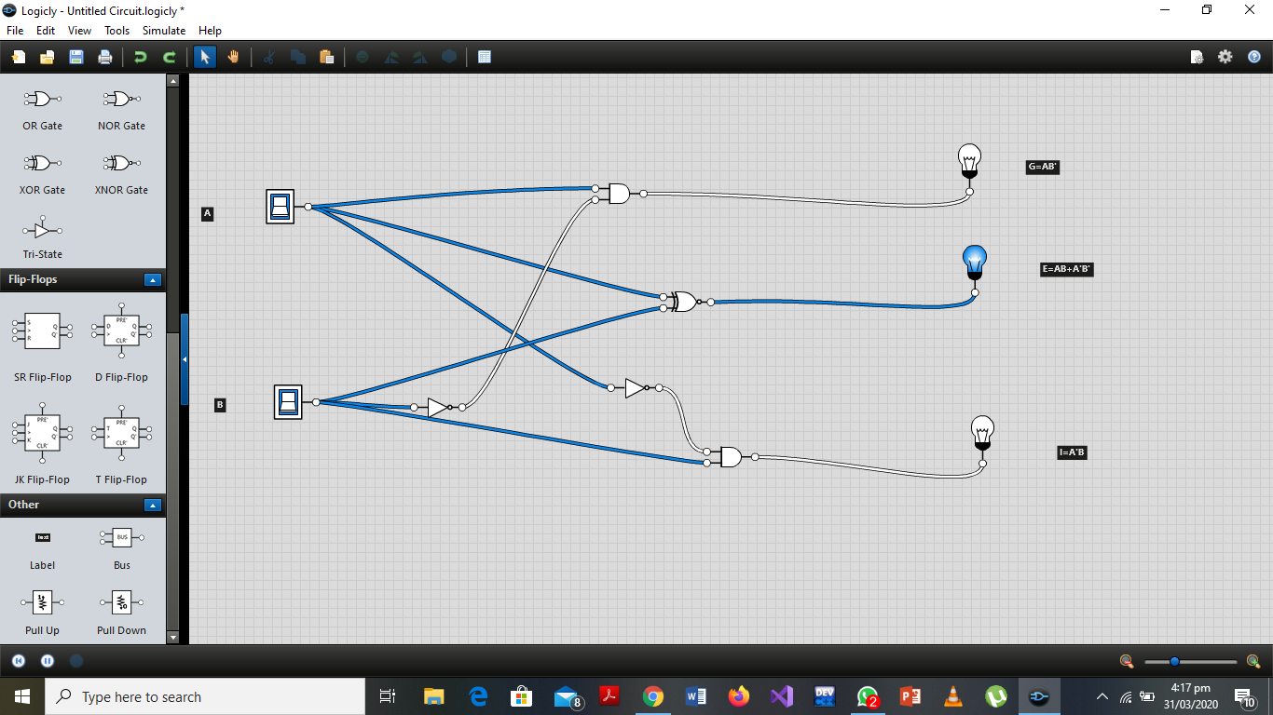

**TASK NO 2:**

**2 bit magnitude comparator:**

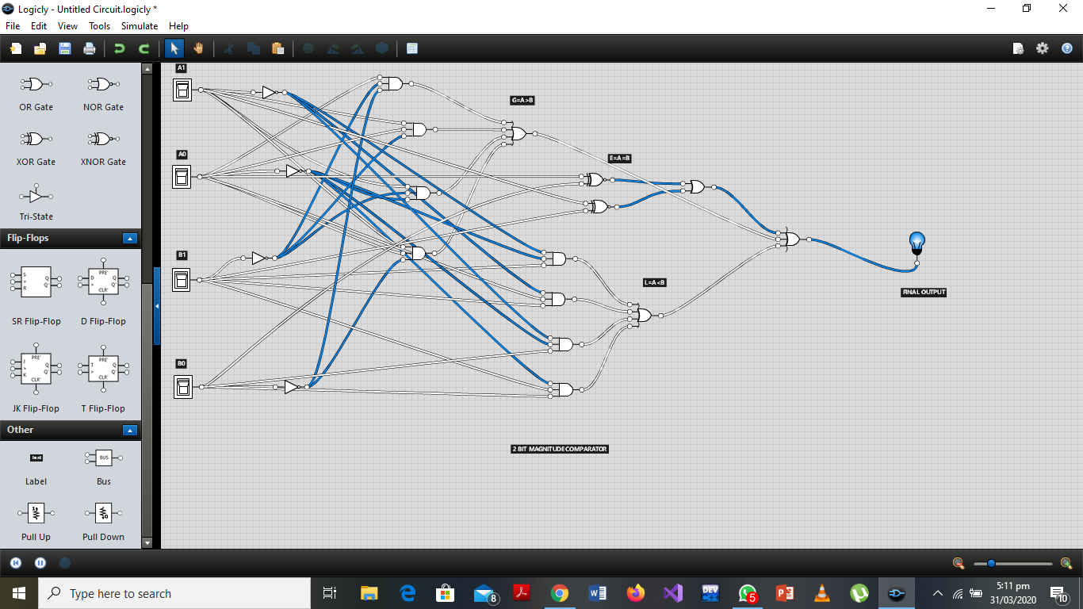

**PAPER WORK OF 1 & 2 BIT MAGNITUDE COMPARATOR:**

**NOTE:**

In 2 bit magnitude comparator,when we simplify the E i.e A=B by taking commons and simplification the final output comes which is Ao xnor B0 & A1 xnor B1,which is easy and make our circuit more efficient ,clear and easily understandable for the others.

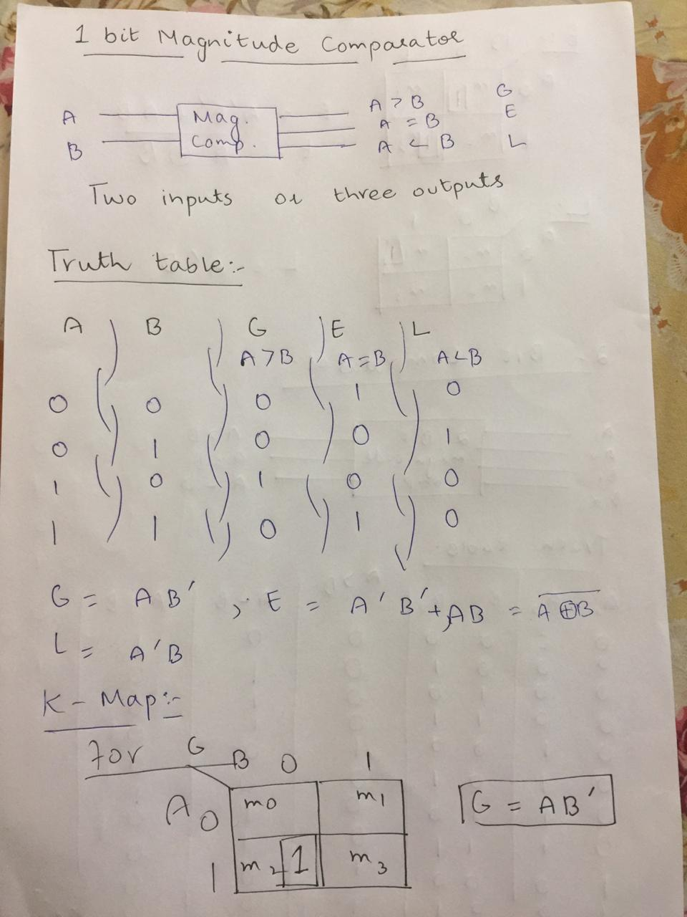

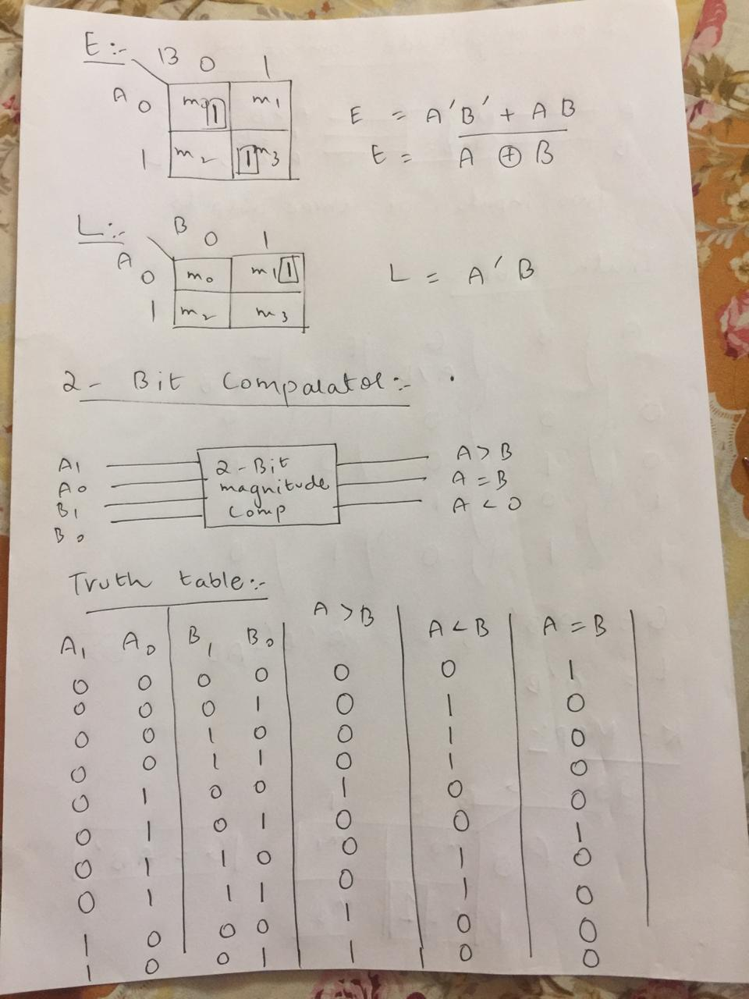

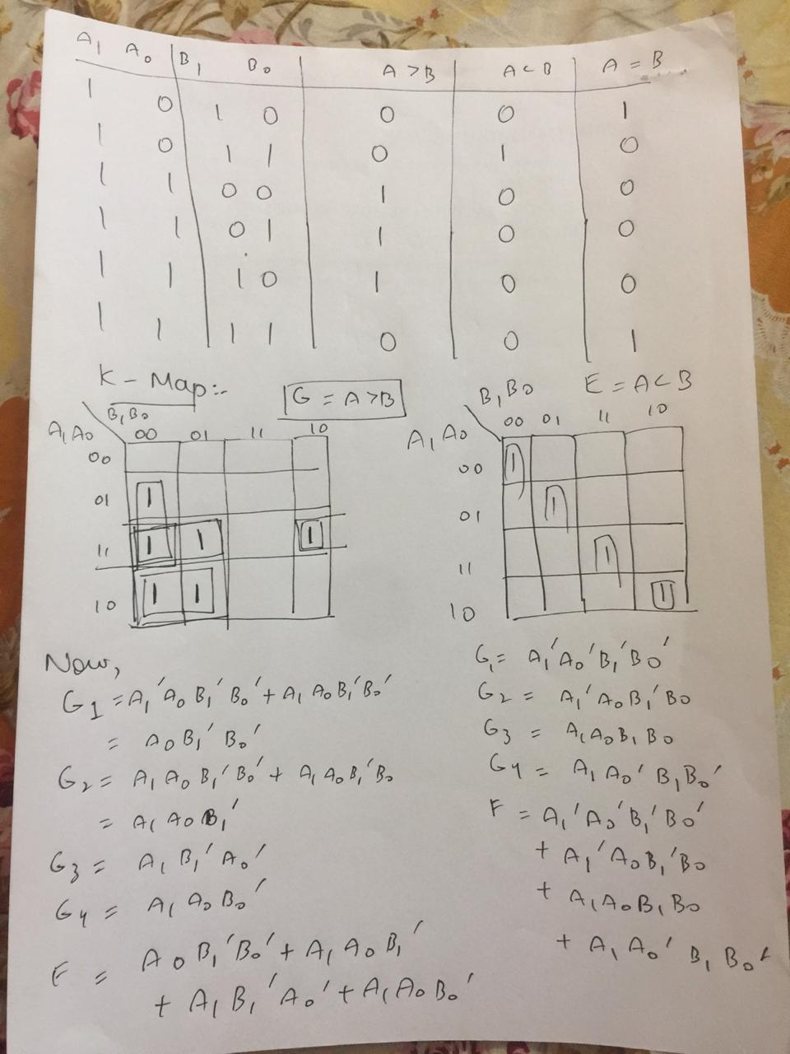

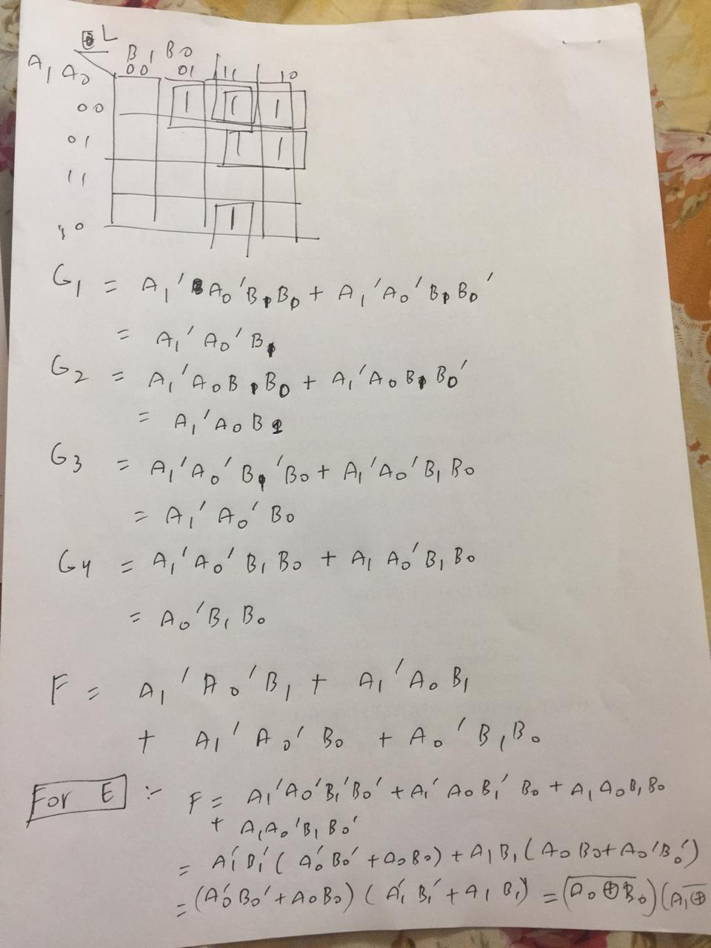

**TASK # 3:**

**4 bit comparator:**

**Paper work:**

**NOTE:**

**Following are the paper work of 4 bit magnitude comparator:**

* **TRUTH TABLE.**
* **FUNCTIONS.**

